Welcome to Blackpool Aspire Academy
PE Department

Meet the PE Team

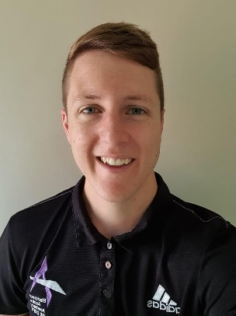
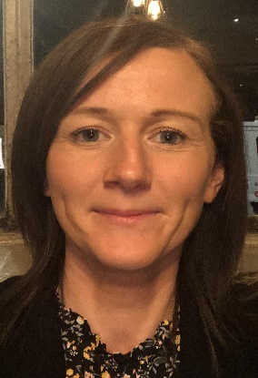

Mr Ryder
Teacher of PE
Mr Brown
Teacher of PE &
Head of Year 7
Mrs Elson
Head of PE &
Director of the Extended Curriculum

Mr Hewitt
Deputy Headteacher
& Teacher of PE
Mr King
Teacher of PE

We would like to get to know you

What is your name

What sports do you currently play?
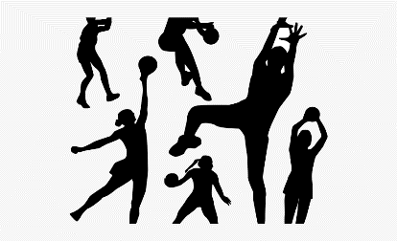

What is your own best sporting moment? Please describe it to us.
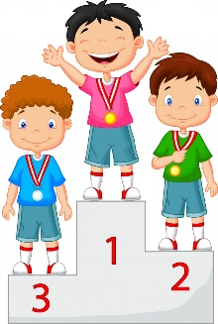

Who is your sporting hero and tell us why?

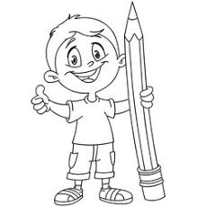
Can you draw or find a picture of them?

What we would like you to do

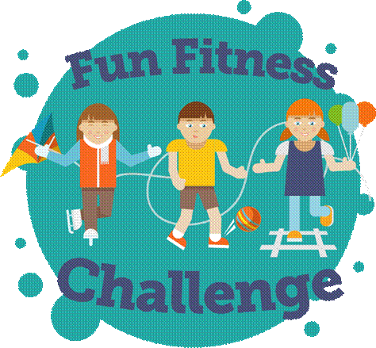

A fitness Challenge

Using the letters of your name complete the exercises associated
with that letter.

For example, if your name begins with a R you would start by
doing 30 seconds of shuttle runs. Then move onto the next
letter of your name.

ALPHABET FITNESS

Spell your name and carry out the exercises for each letter

A = 50 Jumping Jacks N = 25 Burpees

B = 20 Crunches O = 20 Lunges

C = 30 Squat P = 30 secs Ski Jumps

D = 15 Push-ups Q = 30 Sit Ups

E = 1 min Wall Sit R = 30 sec Shuttle Runs

F = 10 Burpees S = 20 Bicep Curls

G = 20 Arm Circles T = 20 Tricep Dips

H = 20 Squats U = 45 secs Battle Rope

I = 30 Jumping Jacks V = 45 secs Plank

J = 30 secs Plank W = 20 Push-ups

K = 30 secs Battle Rope X = 30 Jumping Jacks

L = 30 secs Wall Sit Y = 10 Crunches

M = 30 Mountain Climbers Z = 20 Ball Slams

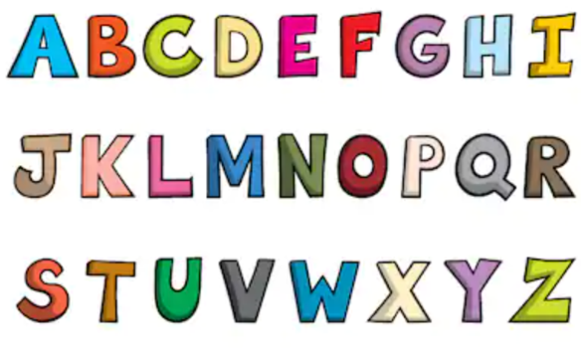

Become a sports reporter!!

Task 1 – Lets develop your verbal skills

Watch one of the following clips and explain to a family member what you have just seen. You need to consider the following:

- What is happening? E.g. which sport, people, sounds, colours, weather
- Who is performing?
- What was the result of what they were doing? E.g. they made a great pass

Give as much information as you can!!
Netball – Helen Housby
Football – Harry Kane
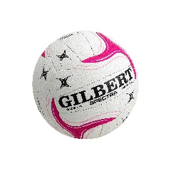

https://www.youtube.com/watch?v=7SK4KIBUVXU
https://www.youtube.com/watch?v=z6rYx_1gKEE

Tennis – Andy Murray
100m – Usain Bolt
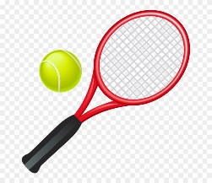
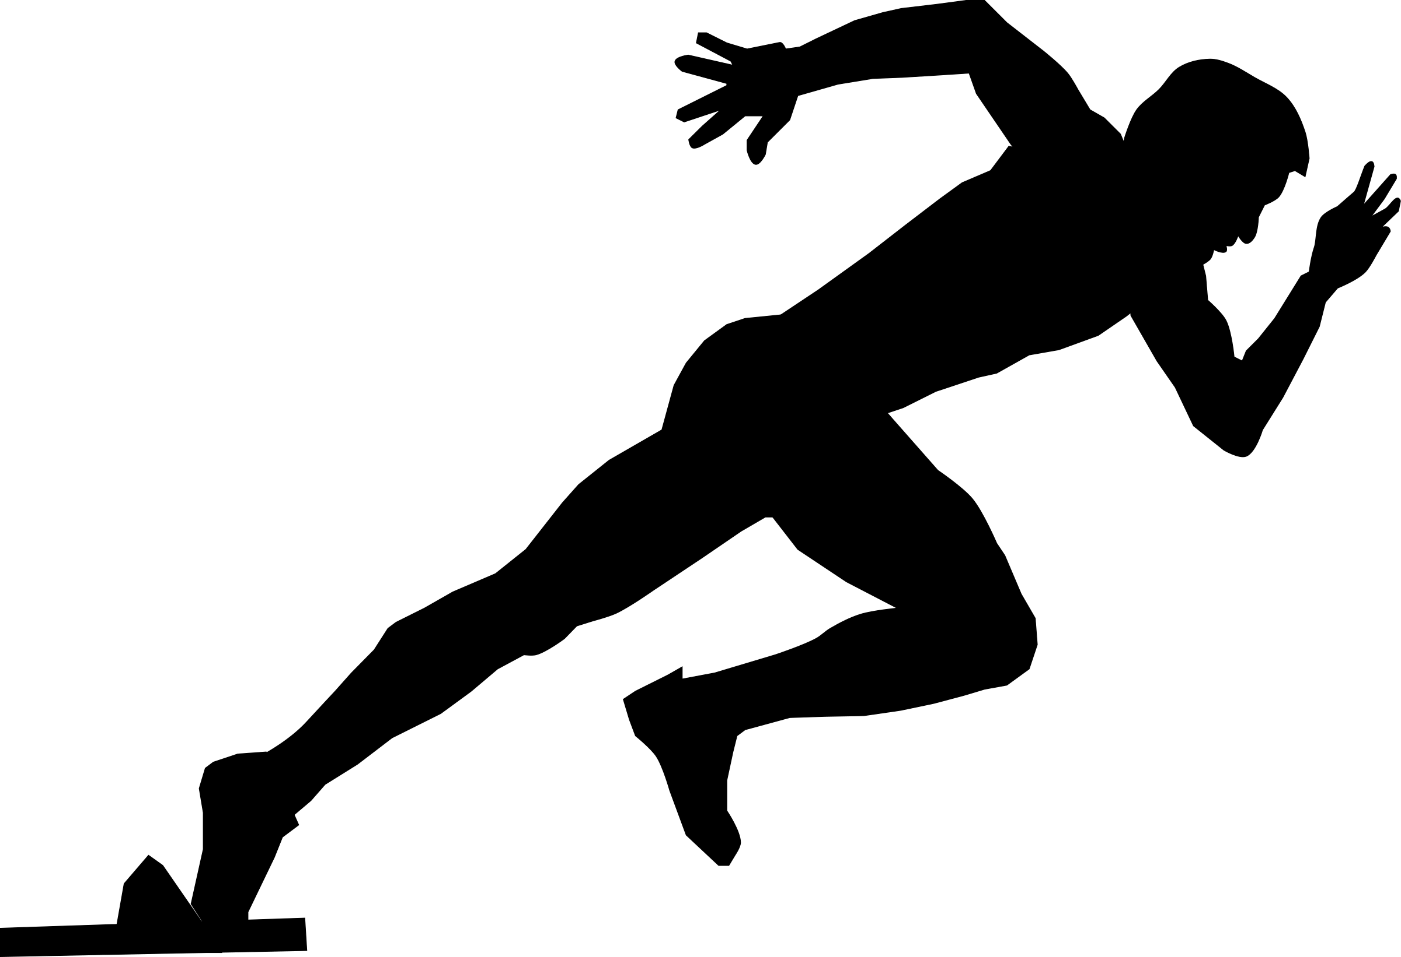

https://www.youtube.com/watch?v=3nbjhpcZ9_g
https://www.youtube.com/watch?v=5p2oci9qTj8

Task 2 – Lets increase your vocabulary for your chosen sport

For which ever sporting clip you have just watched, you are going to mind map key words that are associated with that sport and sports performer.
For example, Long Jump – Preparation, take off, landing, metres, measuring, official etc
Put the name of the sport in the yellow cloud and then place arrows off the mind map cloud to show which key terms are used in your sport.

Task 3 – Skills to be a sports reporter

Read the following sports report that was written about Jenson Button’s win in Canada.

Jenson Button emerges victorious in rain-soaked Canadian Grand Prix

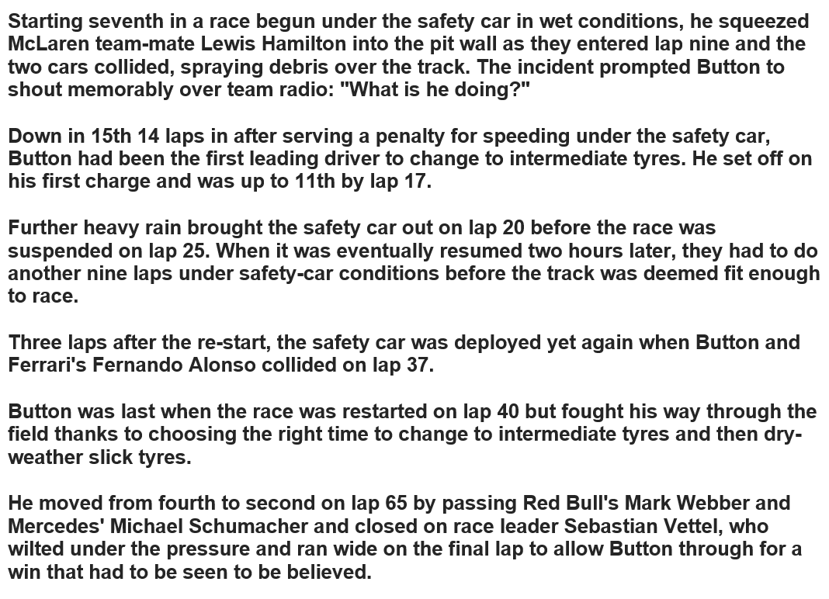
The McLaren driver Jenson Button salutes the crowd after winning the Canadian Grand Prix in Montreal.

Now that you have read through the article can you answer the following questions?

- Which sport was being focused on?

…………………………………………………………………………………………………………………………………………

- Which sports performers were included in the article?

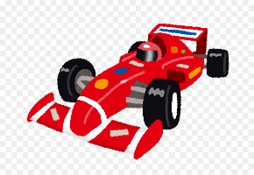
…………………………………………………………………………………………………………………………………………

- Where did Jenson button start at the beginning of the race?

…………………………………………………………………………………………………………………………………………

- Who ended up winning the race?

…………………………………………………………………………………………………………………………………………

- What was the weather like during this race and how did this have an effect?

…………………………………………………………………………………………………………………………………………

- Which two drivers collided and what happened because of this?

…………………………………………………………………………………………………………………………………………

…………………………………………………………………………………………………………………………………………

…………………………………………………………………………………………………………………………………………

- Who does Mark Webber race for?

…………………………………………………………………………………………………………………………………………

- Who is Jenson Button’s racing team mate?

…………………………………………………………………………………………………………………………………………

Hopefully, you can see how descriptive language is important. You were not at the race but
you were able to get a good idea about what happened from the power of words and actual
factual information.

The information was given by someone else who was at the race and they are describing
to you what they saw.

Now its your turn to have a go!!

Task 3 – Writing your own report!!

Watch the video again (and as many times as you like!!) and write a newspaper report on what you have observed.
Remember to consider:

- Who is involved?
- What were the key highlights?
- Was there a score?
- What was the atmosphere like?
- What were they wearing? Do they have a number?
- Don’t forget that you can also add pictures if you wanted to.

…………………………………………………………………………………………………………………

…………………………………………………………………………………………………………………

…………………………………………………………………………………………………………………

…………………………………………………………………………………………………………………

…………………………………………………………………………………………………………………

…………………………………………………………………………………………………………………

…………………………………………………………………………………………………………………

…………………………………………………………………………………………………………………

…………………………………………………………………………………………………………………

…………………………………………………………………………………………………………………

…………………………………………………………………………………………………………………

…………………………………………………………………………………………………………………

…………………………………………………………………………………………………………………

…………………………………………………………………………………………………………………

…………………………………………………………………………………………………………………

…………………………………………………………………………………………………………………

…………………………………………………………………………………………………………………

…………………………………………………………………………………………………………………

…………………………………………………………………………………………………………………

…………………………………………………………………………………………………………………

…………………………………………………………………………………………………………………

…………………………………………………………………………………………………………………

…………………………………………………………………………………………………………………

…………………………………………………………………………………………………………………

…………………………………………………………………………………………………………………

…………………………………………………………………………………………………………………

…………………………………………………………………………………………………………………

…………………………………………………………………………………………………………………

…………………………………………………………………………………………………………………

…………………………………………………………………………………………………………………

…………………………………………………………………………………………………………………

…………………………………………………………………………………………………………………

…………………………………………………………………………………………………………………

…………………………………………………………………………………………………………………

…………………………………………………………………………………………………………………

…………………………………………………………………………………………………………………

…………………………………………………………………………………………………………………

…………………………………………………………………………………………………………………

…………………………………………………………………………………………………………………

…………………………………………………………………………………………………………………

…………………………………………………………………………………………………………………

…………………………………………………………………………………………………………………

…………………………………………………………………………………………………………………

…………………………………………………………………………………………………………………

Thank you for completing this work. We hope you enjoyed it and we are looking forward to meeting you in September.

